Date: 09.04.2021
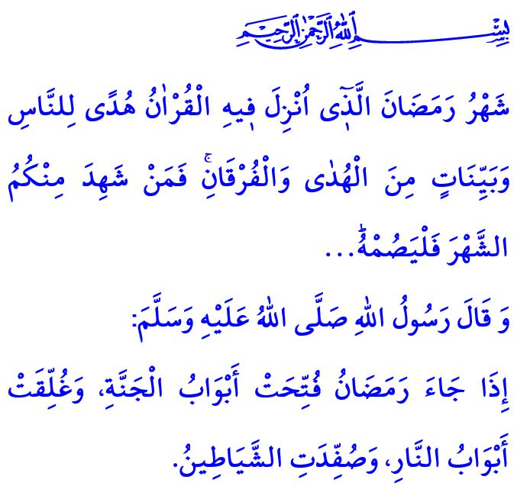
RAMADAN: THE BLESSED GUEST
Honorable Muslims!
In the verse I have recited, our Lord Almighty (swt) states as follows, “The month of Ramadan [is that] in which was revealed the Qur’an, a guidance for the people and clear proofs of guidance and criterion. So whoever sights [the crescent of] the month, let him fast it.”
In the hadith I have said, the Prophet Muhammad (saw) states, “When the month of Ramadan starts, the gates of the heaven are opened and the gates of Hell are closed and the devils are chained.”
Dear Believers!
The month of Ramadan, which is the last of the three holy months as the season of mercy, forgiveness and abundance of divine blessings, and to which we have been looking forward, is just around the corner. On the night the next Monday turns to Tuesday, we will perform the first tarawih prayer and wake up for suhoor, inshallah.
Dear Muslims!
Our blessed guest, Ramadan, is an exalted invitation for us from our Lord (swt). It is a call for us to recite the Holy Qur’an, our guide to the true path, more and contemplate more. It is the best opportunity for us to strengthen our will and discipline our self through fasting. With suhoor and iftar meals, it means peace and abundance of divine blessings in our homes. With tarawih prayers we perform in addition to the five daily prayers, it means health for our body and tranquility for our soul. With the zakat, fitr, and sadaqah we give, it means fondness between our relatives, neighbors and all our brothers and sisters. The greatest responsibility that falls upon us as Muslims in this month is to accommodate this blessed guest in the best place in our hearts and to accept this divine invitation wholeheartedly.
Dear Believers!
Let us calm down our exhausted souls with Ramadan al-Sharif. Let us ask Allah to relieve our depressed hearts. Let us turn to our essence and inside, and increase our sense of servitude to Allah (swt). Let us gird our sense of patience, compassion, contentment and gratitude. Let us promise to protect our hand, tongue, eye, mind, heart, in short, our soul and body, from sins.
Dear Muslims!
Ramadan Kareem! I wish you all a happy Ramadan. May our hearts and intellectual world find healing with the Qur’an. May the month of Ramadan be conducive to humanity overcoming all kinds of troubles and diseases, particularly the pandemic we have been going through.

Baqarah, 2/185.
Muslim, Siyam, 1. General Directorate of Religious Services

